GUIDELINES FOR STRUCTURING AND WRITING ACADEMIC PAPERS

Author: Pankaj Bhagat

Date: 29 June 2024

References: Notes from Classes and online validations.

When writing academic papers, it is crucial to adhere to specific formatting and structural guidelines to ensure uniformity and clarity. This article summarizes the essential elements that should be incorporated into your writing assignments to meet academic standards.

# Title Page

The title page is a critical part of your paper. The title should be in all caps and centre-aligned to create a uniform look across all assignments. This standardization helps in maintaining consistency across submissions. Generally in GSOL the title is longer. It is not as small as “DIVORCE AND MARRIAGE”. It is generally descriptive. So, instead of writing a lengthy description, simply use "WRITING ASSIGNMENT" as the title. 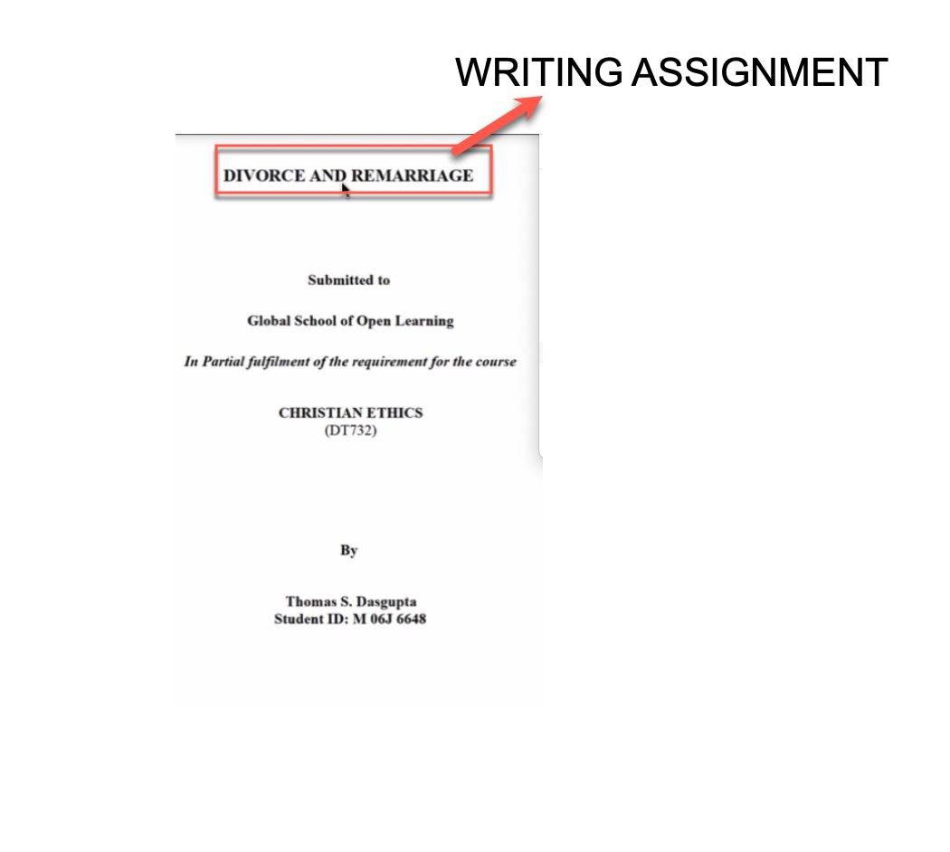 This approach avoids the complexity of varied topics and ensures clarity.

## Formatting of Title Page

Refer to the sample screenshot above.

1. **Overall Formatting**:
   1. Use a readable font like Times New Roman, 12-point size.
   2. The title page should not have a page number.
   3. Ensure that the margins are set to at least 1 inch on all sides.
   4. Page number should be in the footer in the centre. No count of page number. The title page should not have page number.
   5. How to insert page number: See Video here <https://youtu.be/RLcT97o5TBo> or See the gif below



1. **Title**
   1. The title must be in all caps.
   2. The title should be centre-aligned.
   3. The title should be bold.

## Formatting and Structure

A well-structured paper is not just a series of paragraphs. It should include:

1. Introduction:

Start with a short orientation, introducing the topic and providing an overview of the main points. If applicable, include a concise thesis statement outlining the purpose of the paper. 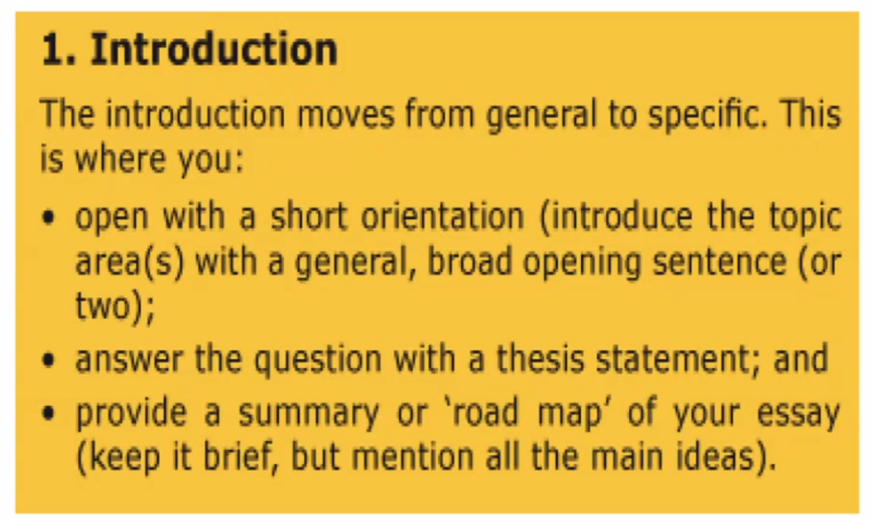

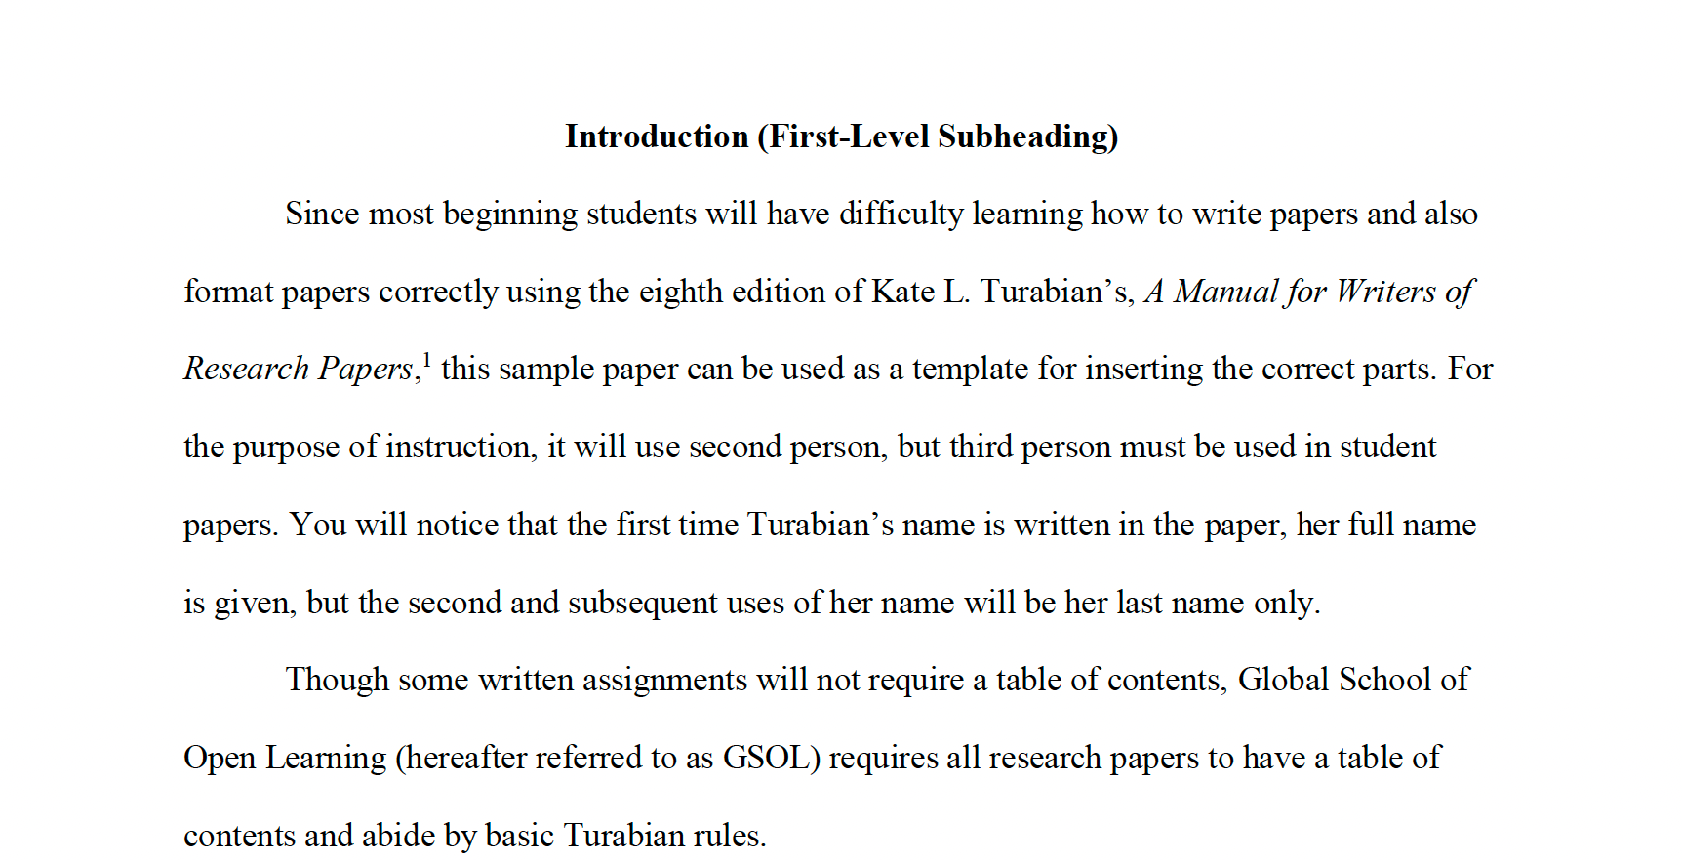

Note:

Ensure all assignments are submitted for review.

• Your facilitator will check the draft, focusing on formatting, grammatical errors, structure, and the conclusion.

• The facilitator’s role includes providing feedback, suggesting corrections, and encouraging revisions.

• Once revisions are complete and you are satisfied, submit the final copy to GSOL or through the center.

• Expect to revise your research paper multiple times.

• Do not hesitate to contact your facilitator for clarification or guidance on specific issues.

* The facilitator is also responsible for detailed feedback, helping you understand and correct mistakes, and advising on proper formatting.

Remember, each facilitator is a qualified guide in academic writing. Take their help seriously. If guidance is lacking, actively seek clarifications and request the necessary corrections. GSOL promotes guided learning to ensure you have support throughout your program. Working alone and submitting without revisions can result in lost marks, which we want to avoid.

Once submitted, the work is graded and cannot be revised; deductions will be made for incorrect formatting and improper citations. It is imperative to make all necessary corrections before submission. The practice of writing an assignment and immediately submitting it is highly discouraged, particularly for research papers. A research paper must be free of errors that could easily be rectified through careful reading. Typographical errors are common, and even this communication may contain such mistakes. Therefore, it is essential to thoroughly review and edit your writing, ideally revisiting the text at least twice to ensure accuracy and completeness.

## Subheadings:

Use bold subheadings to break the text into manageable sections. Subheadings help in outlining the content and are useful for referencing in the table of contents.

Kate L. Turabian’s “A Manual for Writers of Research Papers, Theses, and Dissertations” provides detailed guidelines for formatting headings and subheadings to ensure clarity and consistency throughout an academic paper. Here’s an overview of how to format headings and subheadings according to the Turabian style:

### Formatting Headings and Subheadings:

1. **Levels of Headings:**

• **First-Level Heading**: Centered, boldface, and in headline-style capitalization (capitalize the first letters of each major word). 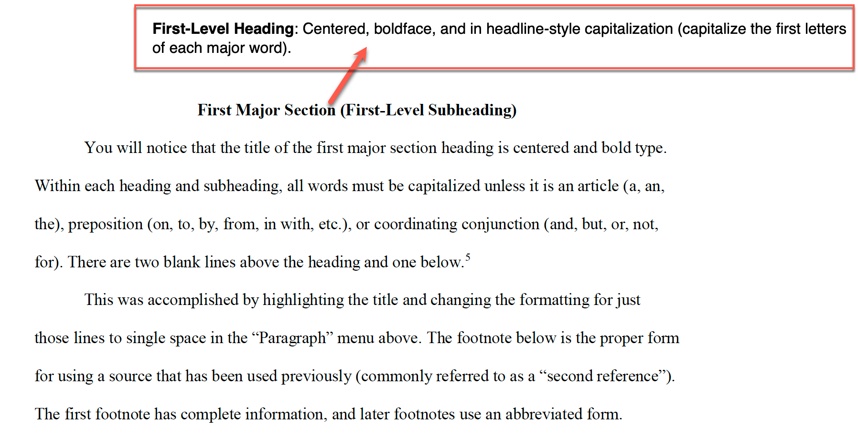

• **Second-Level Heading**: Centered, regular typeface, headline-style capitalization. 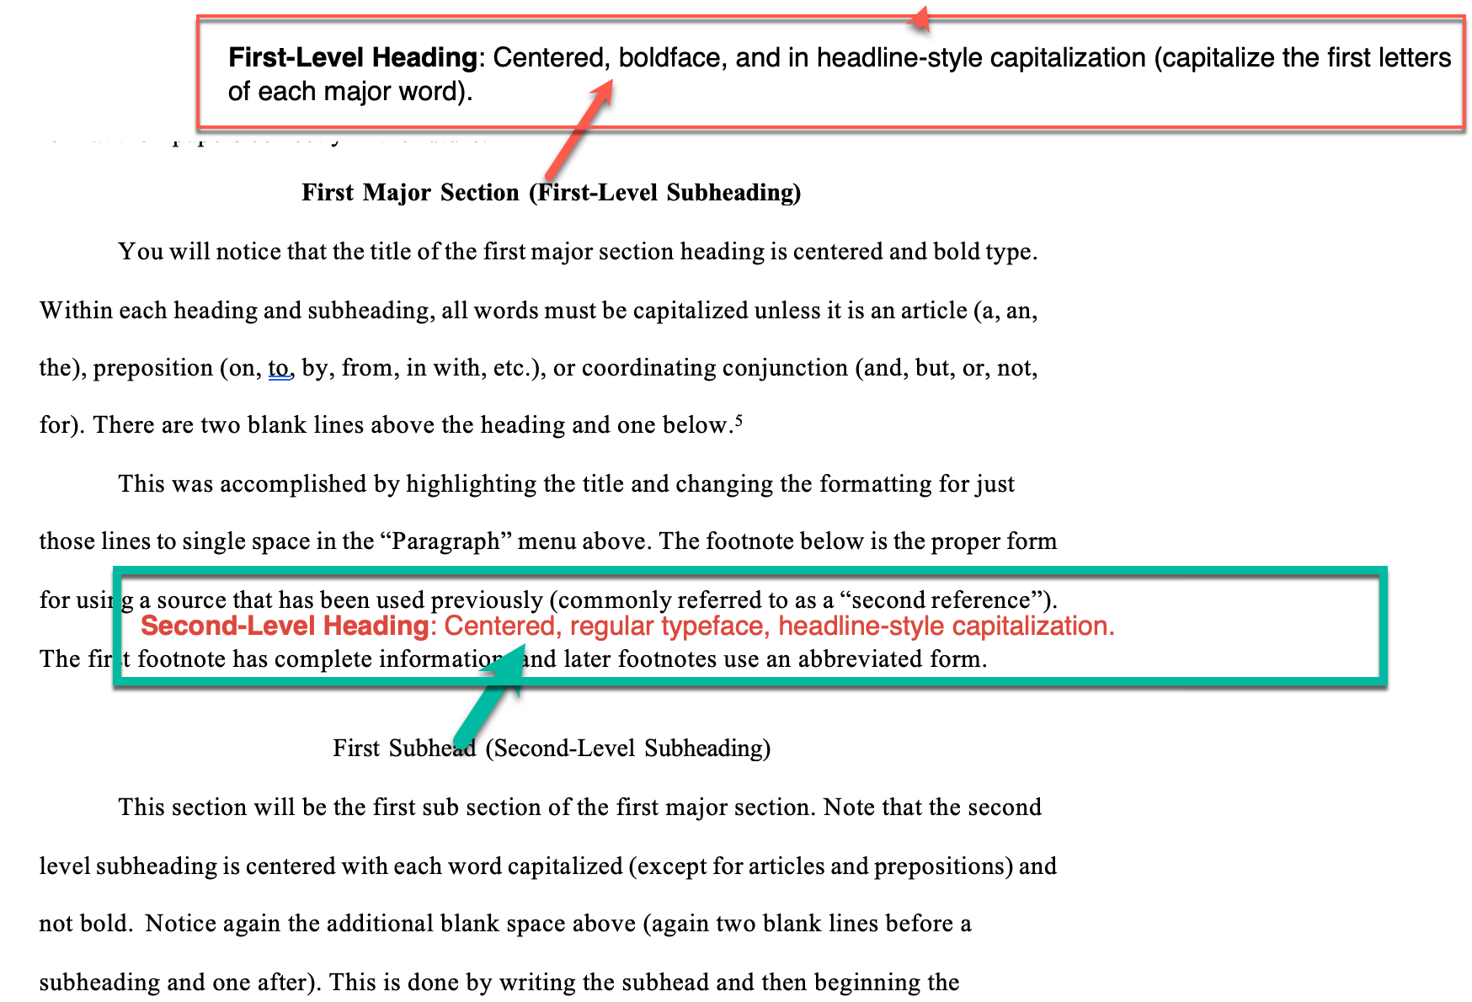

*NOTE: I have not yet added examples to the contents below*

• **Third-Level Heading:** Flush left, boldface, headline-style capitalization.

• **Fourth-Level Heading**: Flush left, regular typeface, sentence-style capitalization (only the first word and any proper nouns are capitalized).

• **Fifth-Level Heading**: Run in at the beginning of the paragraph (no blank line after), italicized, sentence-style capitalization, ending with a period.

2. **Spacing**:

• Headings should be separated from text by a blank line above and below the heading for first and second levels.

• For third and lower-level headings, place them directly above the paragraph they pertain to without extra lines above, though you may include a blank line below if it helps clarity.

3. **Consistency**:

• Consistently use the same style of heading for each level throughout your paper. This uniformity helps readers recognize the organizational structure of your document.

4. **Numbering** (optional):

1. In some academic disciplines, headings are numbered to indicate their position and level within the paper’s structure, such as “1. Introduction”, “1.1 Background”, and so on. (*To be verified)*

Conclusion:

1. Your conclusion should summarize the main arguments and provide a final perspective on the topic. It should align with the introduction, ensuring that all points discussed are wrapped up coherently.

## Content and Citations

**Paragraphs**: Avoid long, unbroken paragraphs. Divide your paper into sections and subsections. If a section consists of more than two paragraphs, consider using a second-level subheading.

**Quotations and Citations:** Direct quotes should be used sparingly. Instead of filling your paper with quotes, provide your analysis and arguments. When citing sources, use proper footnotes and include a bibliography in the correct style. Ensure that you use a variety of academic resources, such as peer-reviewed journals, books, and credible websites.

## Writing Style

**Academic Tone**: Use an academic tone and third-person language. Avoid informal language and ensure your paper is written in a clear, concise manner.

Grammar and Punctuation: Proofread your paper to correct grammatical errors, spelling mistakes, and punctuation. Avoid submitting your paper at the last minute to ensure you have time to review and refine your work.

**Plagiarism and Paraphrasing**

Plagiarism is a serious offense in academic writing. Whether you use direct quotes or paraphrase information, always cite your sources. Even when paraphrasing, you need to credit the original source through footnotes and a bibliography. Avoid copying and pasting text from your sources; instead, express the ideas in your own words and provide appropriate citations.

**Research and Resources**

For research papers, use a variety of sources to support your arguments. Do not rely solely on the textbook. Incorporate different types of academic resources to provide a robust foundation for your paper. Ensure that your research is thorough and that you synthesize information from multiple sources to present a well-rounded argument.

## Conclusion

In summary, your academic paper should be well-structured, properly formatted, and free from plagiarism. By following these guidelines, you can create a coherent and professional paper that meets academic standards. Remember to proofread your work, use a variety of sources, and maintain an academic tone throughout your writing.

By following these guidelines, students can ensure that their academic papers are well-organized, properly cited, and free from plagiarism, ultimately reflecting a high standard of academic writing.